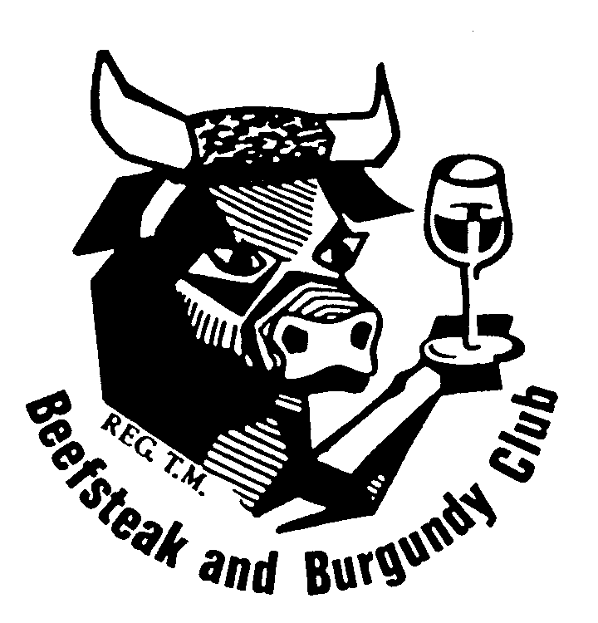 | BURNSIDE BEEFSTEAK & BURGUNDY CLUB  COMMITTEE MEETING  TUESDAY 1 June 2021  TO BE HELD AT CAROLYN PALMER’S RESIDENCE  6 Ocean Avenue, West Beach  AT 6.00 PM  Minutes

- Present: Ken Ridley [Chair], John Swift [Cellarmaster], Carolyn Palmer, Saul Gilbert, Tom Mittiga.
- Apologies: Di Betterman, Tony Scholefield

- Confirmation of Minutes of Last Meeting

Proposed: Tom Mittiga

Seconded: Saul Gilbert

- Matters Arising
- Proposed changes to the club’s constitution (John)
- The proposed new Constitution and Rules were tabled at the Special General meeting held on 12 May 2021. The following motion was put: “That the Constitution and Rules of the Club be rescinded in their entirety and the document tabled at this meeting be adopted in lieu thereof”. The motion was moved by C Palmer and seconded by R Bowes. As there was no speaker against the motion it was put to the vote by show of hands and carried unanimously as a Special Resolution.

- The application was lodged on 13 May 2021 electronically. John was informed there was a 12-week backlog of applications. No receipt has been received. John will follow up by phone. If no response he will lodge a hard copy. Noted that the constitution is not active until it has been registered.
Action: John

- January function organisers:

- Leonie and Saul have volunteered to organise the January 2022 function.
Action: Leonie and Saul

- Correspondence
In
  - Email from Peter Murton Committee membership: would like his name put forward at the AGM; Carolyn to email Peter in response to his email informing him that the two vacancies will be held over to the AGM.

Action: Carolyn

  - Email to John Swift from Craig Thornquest re Constitution authorisation

  - Email to John Swift from the Attorney-General’s Department re Change of Public officer Particulars

Out –
- May Newsletter; 2022 Echuca Convention - May 2021 Newsletter

6. Membership
23 active members plus 1 inactive member (Tim Ryan) plus 5 active life members (Bob Bowes, Lee Miller, Leone Scholefield, John Swift and Vin Thomas) plus 5 inactive life members (Peter Baturin, Bob Brinkworth, Darrol Fullgrabe, Tom Muecke, and Bill Seppelt).

7. Vacant positions (Secretary and Treasurer) (Ken)

- An invitation to members to send expressions of interest in nominating for Secretary, Treasurer or one of the two vacant committee positions is to be forwarded to members by the Secretary requesting responses by the end of July. The Secretary will attach these to the Agenda for the 10 August meeting.

Action: Carolyn

8. Finance Report (Di)
See attached
Balance as at 31st May 2 Balance as at 30th April 2021

Trading Account $ 4,251.43 $ 4,553.43

Term Deposit $11,058.12 $11,055.42

TOTAL $15309.55 TOTAL $15,608.85 ($299.30)

Payments during May - $3047.00

10th May | EFT | $ 79.80 | Paid to J Swift re wine purchased
13th May | EFT | $ 510.27 | Paid to Saul Gilbert re wine purchased
17th May | EFT | $ 16.93 | Paid to Saul Gilbert re freight
18th May | CHQ | $2440.00 | Paid to D Betterman re refund May dinner

Receipts during May $2747.70
Payment for May Dinner $2745.00
Interest $2.70

Income $2747.70 less payments Debited $3047.00 = $299.30 Deficit Subs/Cellar Fees
At the end of October all members had paid their subscriptions/wine levies

Function Outcomes

For the May function, there was a cash surplus of $280.00 and taking into the cost use of the 24 bottles from the cellar at $7.00 bottle, a function surplus of $112.00

The cash result of $280.00 less the purchase cost of the wines from the cellar of $535.24 resulted in a $255.24 subsidy from the club cellar for the function.

Thus, for the year to date, the “real” results of functions is an asset loss of $4481.58

Outstanding

Lorraine Curtis and partner paid $170.00 – did not attend due to illness – we were not charged. Contra next function.

Budget Progress

As noted above, so far this budget period $4481.58 of wine has been used from the cellar. Below it can be seen that $2326.98 has been purchased as replacement purchases, leaving $2154.60 still to be replaced.

The remainder of the wine purchase budget is $673.02 leaving $1481.58 to be drawn from reserves, if the equivalence is to be purchased, as against reducing the quantity of the cellar. All this obviously assumes, like for like replacement, which would not be the case, but it gives some perspective.

Please note: The Penfolds Wine (purchased for the 70th birthday celebration) and freight have been added to the Wine Budget 20/21 for audit purposes. This can be adjusted if it is decided we will have a 70th birthday budget.

2020/2021 BUDGET

Income

Subscriptions $820 $920
Cellar Levy $3180 $3240
Function Surplus $2000 $2008.60
Wines Sales $0 $0

Total $6000 $6168.60

Expenditure

Wine Storage $1320 $1320
Stocktake $0 $0
Cellar Wine Purchase $3000 $2326.98
Administration $150 $89.50
Affiliation Fee $250 $250
Name Badges $100 $132
Medals $120 $66
Trophy Wines $600 $707.69
Incidentals $150 $60
Function Subsidy $310 $255.79

Total $6000 $5207.96

Surplus $960.64

The maturity date for the Term Deposit is the 16th August 2021.

Acceptance of the Treasurer’s Report
Moved: Tom Mittiga

Seconded: Saul Gilbert

9. Cellar Report (John)

- Recommendations:
  - That the format of the 70th Anniversary Dinner not be like the 60th but rather dedicate the two usual Gourmet Functions in July and December and hold one other of similar quality on 20/2/26 to record the milestone with a specially selected reservation of quality wine.

Moved: John
Seconded: Tom

  - That wines for the 70th be specifically purchased and placed on reserve, and each CSC member email the Chairman by 10/5/21 with their choice of wines for the 70th
  - That the Tom purchase 4 bottles of Tyrrell’s 2010 Hunter Valley Semillon. Action: Tom
  - That Saul purchase some SC Pannell Nero d’Avola. Action: Saul
  - That the previous practice of bringing a wine to committee meetings that is suitable for Club cellar purchase be reinstated
  - That each member of the General committee provide their recommendations for wine to purchase for the cellar
  - That in 2022, the April function be a dinner with gourmet quality wine – suggested it should be called a Cellar Selection Night.
  - That the Secretary advertise in the Newsletter to source a bottle of the Landhaus 2017 Mourvedre/Grenache to add to the five bottles currently in the cellar.

- Budget:

- John noted:
  - that the budget allocation needs to be spent: whatever is not spent needs to be moved on to the following year’s budget
  - Some good quality Pinot Noir is needed

Acceptance of the Cellar Master’s Report
Moved: John
Seconded: Tom
- Minutes of the Meeting of the Cellar Sub-Committee

See attached

10. Functions

- May (Keisman/Mittiga) (Tom) – successful function

The wines chosen for the Dinner were:

  - Aubert et Fils Champagne NV Brut
  - Mesh, 2008 Clare Valley Riesling
  - Pikes 2009 Clare valley Riesling
  - Rusticana, 2010 Langhorne Creek Durif
  - Brothers in Arms 2012 Langhorne Creek Malbec
  - Virgara, 2000 Adelaide Plains Shiraz

  - The wines received positive comments, although some posed some identification challenges.

  - June (McPhee/Hani): Venue - HISPANIC MECHANIC. Flyer and menu forwarded to members

  - July (Robinson/Swift) (John) – Venue Kooyonga Golf Club

  - October Weekend Away 15-17 October (Thomas/Betterman)

Accommodation will be nominated in Tanunda for members to personally book. The Friday and Saturday night functions will be held in Tanunda. Two wineries will be visited on the Saturday morning (possibly alternatively), a light lunch and tasting will be held at a third winery, while after lunch a fourth winery will be visited. It is expected between 3.30 and 6.30 members will have free time. On the Sunday morning one winery will be visited, followed by a light lunch and tasting at another winery to conclude the weekend. It is envisaged that the winery selection will move from the southern Barossa Valley area through to the Greenock area on the Sunday.

A notice detailing the above, possible accommodation and possible costs will be sent to members in the near future, seeking an indication as to whether they will attend.

The point was made that an indication should be received of who will be tasting, so that the tasting costs are not unnecessarily incurred.

Feedback from the Committee:
General consensus:
- the weekend is too expensive: Concern that the cost would limit participation
- Two Gourmet dinners are not needed
- Recommend a Pub/Club meal on the Friday evening
- Carolyn to contact Di and Vin and convey the Committee’s concerns
Action: Carolyn

11. Any Other Business
a) 42 rule and single member guest partner status

- Committee dinner in August is now Tues. 10th. at the Caledonian Hotel (Ken)

- Dress at meetings: “smart casual” rather than “casual dress” – does not mean Jeans (Ken)
Action: Carolyn

12. Ongoing Matters Requiring Implementation
New Directions
- That occasionally the Club seek to have a joint dinner or lunch with another Club(s) or invite another club(s) to join us for our dinner or lunch meeting.
- That the Club monitors that it has some themed/ethnic functions, eg: Greek, Italian, French, German, Thai, Vietnamese, Japanese, Chinese, etc.

13 Next Meeting: Tuesday 6 July 2021 at John Swifts
Food in July: John
Wine in July: Wine suitable for the Cellar

Future Committee Meetings
6 July, 10 August

Meeting closed: 8 10pm

Wines Consumed:

Ken Ridley | 2019 | Mt Pleasant Elizabeth Semillon | Hunter Valley
Tom Mittiga | 2010 | Tyrrell’s Semillon | Hunter Valley
John Swift | 2004 | Tempus Two Zenith Semillon | Hunter Valley
Saul Gilbert | 2014 | Mt Pleasant Philip Shiraz | Hunter Valley

Food Roster Wine
September Vin Thomas Chardonnay/Cabernet Sauvignon
October Carolyn Palmer Riesling/Shiraz
November John Swift Gruner Veltliner/Pinot Gris/Grigio/Noir
December Di Betterman Semillon/Grenache/Sparkling
January President Members’ Choice
February John Swift Arneis/Sauvignon Blanc/Merlot/Malbec
March Tony Scholefield Western Australia
April Saul Gilbert Victoria
May Meeting cancelled
June Carolyn Palmer NSW
July Tom Mittiga South Australia
August Restaurant Members’ choice

FUNCTIONS AND ORGANISERS
2021

DATE | FUNCTION | VENUE | ORGANISER | ORGANISER
17 January | Winery Lunch | Svargo Cucina | Raylene Sutton | Committee
20 February | Dinner | Ayers House | Lee Miller | Carolyn Palmer
14 March | President’s Lunch | Mt Osmond GC | Ken Ridley | (MP) Leone Scholefield
18 April | Lunch | Martini’s Ristorante | Lorraine Curtis | Saul Gilbert
12 May | Dinner |  | Jeremy Keisman | Tom Mittiga
9 June | Dinner | Hispanic Mechanic | Charles McPhee | Judy Hani
14 July | Gourmet Dinner |  | Sue Robinson | John Swift
21 August | AGM |  | Bob Bowes | (NT) Simon Lumsden
8 September | Dinner |  | Taras Mular | Ingrid Allison
15-17 October | Weekend Away | Barossa Valley | Vin Thomas | Di Betterman
14 November | Lunch |  | John Cruickshank | Peter Murton
8 December | Gourmet Dinner |  | Stephen Thomas | Tony Scholefield

Members not as yet assigned: Tim Ryan, Anita Smith, Jenny Wild, Rene Young

