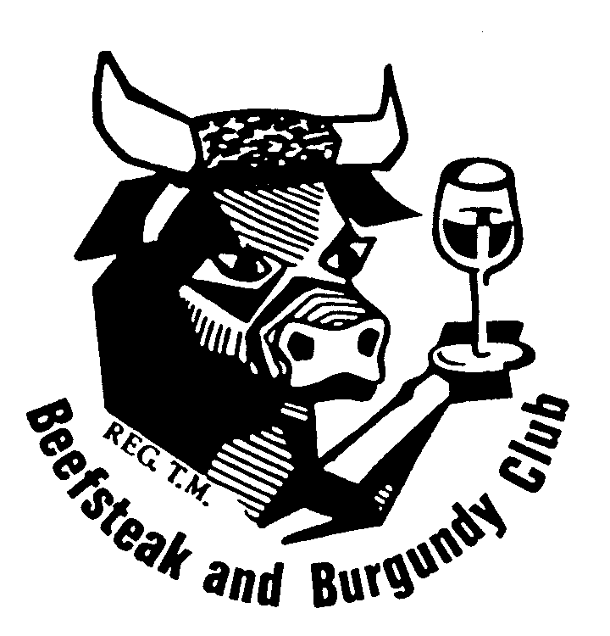 | BURNSIDE BEEFSTEAK & BURGUNDY CLUB  MINUTES OF COMMITTEE MEETING  6 NOVEMBER 2020  HELD AT THE CELLARMASTER’S RESIDENCE
Meeting opened at 6.12 p.m.

Present
Ken Ridley [Chair], Tony Scholefield [Deputy President], Vin Thomas [Secretary/Treasurer], John Swift [Cellarmaster], Carolyn Palmer, Di Betterman.

Apologies
Saul Gilbert, Simon Lumsden.

Minutes
Moved (Betterman/Swift) that the October Committee meeting minutes are a true and correct record.

Motion carried.

Business Arising
Function Organisers
The Secretary reported that he had correspondence yesterday with Raylene Sutton about the January function; she was considering possibilities but made no query re a co-organiser. He had told her that she should make the running and we would assist her. Agreed that Vin Thomas will maintain contact and the committee will support her as necessary. ACTION

2021

DATE | FUNCTION | VENUE | ORGANISER | ORGANISER
17 January | Winery Lunch |  | Raylene Sutton | Committee Members
20 February | Dinner |  | Lee Miller | Carolyn Palmer
14 March | President’s Lunch | Mt Osmond GC | Ken Ridley | (MP) Leone Scholefield
18 April | Lunch |  | Lorraine Curtis | Saul Gilbert
12 May | Dinner |  | Jeremy Keisman | Tom Mittiga
9 June | Dinner |  | Charles McPhee | Judy Hani
14 July | Gourmet Dinner |  | Sue Robinson | John Swift
21 August | AGM |  | Bob Bowes | (NT) Simon Lumsden
8 September | Dinner |  | Taras Mular | Ingrid Allison
15-17 October | Weekend Away | Barossa Valley | Vin Thomas | Di Betterman
14 November | Lunch |  | John Cruickshank | Peter Murton
8 December | Gourmet Dinner |  | Stephen Thomas | Tony Scholefield

Members not as yet assigned: Tim Ryan, Anita Smith, Jenny Wild, Rene Young

Proposed changes to the club’s constitution
John Swift advised the Committee that the Constitution document has not yet arrived.

Auditor’s role description including feedback after a function
The Cellarmaster proposed that the Auditor’s role description include feedback after a function. He will draft the role description, including that component. Agreed. ACTION

Cost of Sparkling Wines for functions
Following discussion, the following recommendation was carried: That at least 4 flights of wine, of which two flights are to come from the mandatory list, are to be taken from the cellar for each function, other than the January winery lunch and the March President’s lunch; and that any wines purchased at the time for the remaining flights are to be charged to the function at purchase price, unless it is a sparkling wine or champagne $30 or over, which will have their price to be charged to the function reduced by a subsidy of $14 per bottle.
Moved Thomas/Betterman.

It was agreed that cheaper champagnes will be purchased for the cellar and when used would be charged to a function at $7, the same as any other flights from the cellar. Moved Thomas/Betterman. Carried.

Correspondence
In – Expressions of interest from John Hillier, Margot O’Donnell, Lee Miller re February 2021 function
Out – October Newsletter; Email responses to John Hillier, Margot O’Donnell

Membership
23 active members plus 1 inactive member (Tim Ryan) plus 5 active life members (Bob Bowes, Lee Miller, Leone Scholefield, John Swift and Vin Thomas) plus 5 inactive life members (Peter Baturin, Bob Brinkworth, Darrol Fullgrabe, Tom Muecke, and Bill Seppelt).

Finance report
The Treasurer distributed the following report prior to the meeting:

Balances as at 31 October 2020 Balances as at 30 September 2020
Trading Account $6,950.51 $6,025.39
Term Deposit $11,028.99 $11,028.99
Total $17,979.50 $17,054.38 $925.12

Payments during October - $4,364.88
7 October EFT $78.25 John Swift reimbursement for Club Constitution
16 October EFT $136.63 John Swift reimbursement for BBN wines
17 October Chq 147 $3,675 Kooyonga GC
28 October EFT $475 On-payment to V Thomas for CMcP wines from Holdfast Club
TOTAL $4,364.88

Receipts during September - $5,290
Payments for October dinner $3,555
Payments for November dinner $820
Charles McPhee payment for Holdfast Wine $475
Annual Subscription $80
Cellar Levy $360
TOTAL $5,290

Income $5,290 less Payments Debited $4,364.88 = Surplus of $925.12

Subs/Cellar Fee
At the end of October all members had paid their subscriptions/wine levies.

Function Outcomes
For the October function, as there were no cellar wines used and the function payment charged to attendees was the same as the venue charged, the cash result was zero, as was the “real” result (cost of wines used from cellar less cash result).

For the year to date, the “real” result of functions is a loss of $1,704.72.

The Finance Report acceptance was moved Scholefield/Palmer. Carried.

Cellar Report
The Cellarmaster reported that he purchased 1 dozen 2017 Olsen Six at $20 a bottle ($240).

Functions

- October (Swift/Loxton)
A Better Bottle Night, held at the Kooyonga Golf Club. All agreed that it went very well, with some very good wines brought. There was a concern that it wasn’t a good Covid environment, crowding around the tasting table. There was discussion about improvements for future years, including just have the one champagne, not multiple wineries, having better access to tasting and possibly having pourers for each bottle to limit the pour.

- November (Mular/Young)
To be at Jarmer’s Kitchen.

- December (Vin Thomas/Saul Gilbert)
The Grange Golf Club has been booked and a $200 deposit paid.

- January (Raylene Sutton/TBD)
The Secretary reported that Raylene had made enquiries at Goldings and wondered about Tomich Wines, but food may be an issue. The Secretary suggested having a look at Lambrook Wines, at Magill Road St Peter’s.

- February (Miller/Palmer)
Lee emailed re purchase of champagne, payment for the champagne purchase and Covid venue size limiting invitation of guests. Agreed that the Secretary would respond affirmatively to the requests.
ACTION

Any Other Business
January Committee Meeting and Lunch
It was agreed that the Committee meeting and lunch should be held on Sunday10 January at the President’s residence at Encounter Bay. Accommodation for the Sunday night and, if wished, the Saturday night is available at Ken’s, Carolyn’s or Tony/Leone’s. The Secretary is to inform Saul and Simon of the arrangement. ACTION

Past Members
It was agreed that Tony Scholefield would send Ken Ridley, Vin Thomas, Carolyn Palmer and Lee Miller the member.doc of membership lists from the club website. ACTION

The Secretary indicated he would do an excel membership list for members’ convenience. ACTION

Ongoing Matters Requiring Implementation
New Directions
- That we contact past members to find out their current situation and if they are interested in attending a future meeting; the recommendation be actioned by the Secretary. That the Club have “past members” nights by special invitation.
- That at least annually the Club have a joint dinner with another Club(s) or invite another Club(s) to join us for our dinner.
- That the Club monitors that it has some themed/ethnic functions, eg: Greek, Italian, French, German, Thai, Vietnamese, Japanese, Chinese, etc.
- That the Club plan to have an annual informal function, eg: BBQ, 'cocktail' function with finger food, etc.
- That the Club invites its function organisers to ensure its food and wine matching choices include more lamb, pork, duck, seafood rather than a focus on beef.
- That the Club lift the focus on increasing wine knowledge by encouraging function organisers to provide more information on the featured wines.
Next Meeting: Tuesday 1 December at Di Betterman’s residence at 6.00pm

Food in December: Simon Lumsden
Wine in December: Semillon/Grenache/Sparkling.

Future Committee Meetings
10 January, 2 February, 2 March, 6 April, 4 May, 1 June, 6 July, 3 August

Meeting closed: 7.45 pm

Wines Consumed

Di Betterman 2019 Hahndorf Hill White Mischief Adelaide Hills Gruner Veltliner
Saul Gilbert Apology
Simon Lumsden Apology
Carolyn Palmer 2017 Hentley Farm Brass Monkey Barossa Valley Pinot Grigio
Ken Ridley 2009 Lowburn Ferry Central Otago NZ Pinot Noir
Tony Scholefield 2014 Stoney Rise Tasmania Gruner Veltliner
John Swift Food 2018 Hahndorf Hill Adelaide Hills Gruner Veltliner
Vin Thomas 2019 Riposte The Dagger Adelaide Hills Pinot Noir
Leone Scholefield 2009 Barratt The Bonython Adelaide Hills Pinot Noir

2020 Function Organiser List

DATE | FUNCTION | VENUE | ORGANISER | ORGANISER
19 January | Lunch | Lambert Winery | Lee Miller | Ingrid Allison
12 February | Dinner | Stamps | Tim Ryan | Anita Smith
15 March | Presidents Lunch | Mt Osmond GC | Ken Ridley | (MP) Saul Gilbert
19 April | Lunch | Cancelled | Carolyn Palmer | Peter Murton
13 May | Dinner | Cancelled | Simon Lumsden | Bob Bowes
10 June | Dinner | Cancelled | Di Betterman | Jeremy Keisman
8 July | Dinner | Martini Restaurant | Simon Lumsden | Bob Bowes
12 August | Gourmet | Treasury 18 | Carolyn Palmer | Peter Murton
22 August | AGM | Living Choice | Committee | (NT) Bob Bowes
9 September | Dinner | Sprout Health Studio | Di Betterman | Jeremy Keisman
16 October | Better Bottle Night | Kooyonga GC | John Swift | Hayden Loxton
11 November | Dinner | Jarmer’s Kitchen | Taras Mular | Rene Young
9 December | Gourmet | Grange GC | Vin Thomas | Saul Gilbert
Spare: John Cruickshank, Judy Hani, Charles McPhee, Lorraine Curtis, Tony Scholefield

